<http://echonewspaper.com.au/towering-fire-defence/>

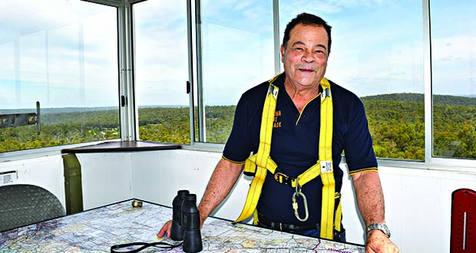

# Towering fire defence

Posted by: Sarah Brookes, mid Dec 2015

WITH the bushfire season underway, a small group of frontline firewatchers are back at work watching for the first signs of fire, perched high above the forests in Bickley and Bullsbrook.

Darlington resident Willem Heyneker and Millendon resident Tony Hoffman are both in their third season guarding vast areas of forest from the top of the Bickley fire tower, which is 30m high.

Mr Heyneker, a contemporary jeweller and wildlife photographer, said many people had no idea the fire towers were still manned. The former pilot, who reported smoke from the devastating fire that razed 57 homes in Parkerville and Stoneville in 2014, said he was terrified of heights.

“The worst part is the climb in the morning but then you get into a routine providing hourly forecasts and weather observations,” he said.

“When there is a stiff easterly wind it’s an interesting experience as the tower shakes, rattles and rolls.

“And you never get used to the lightning strikes.

“Once I saw a strike on the nearby Perth Observatory and it lit up like a Christmas tree.”

Mr Hoffman, a volunteer firefighter with the East Swan Brigade, said it was the perfect job for a writer or a poet.

“Unfortunately I am neither but the solitude has given me time to do an online computer course, read and learn how to tie knots,” he said.

“And the view is spectacular and on a clear day you can see across to Rottnest.”

Mr Heyneker said it was by chance that he landed the job as a towerman.

“I was jogging up a local walk trail when I met a fire spotter who was about to leave the job,” he said.

“I had to do training for working at heights and learn how to use a safety harness and attach myself to the steel cable so I can climb the ladder to the top.”

Mundaring-based Department of Parks and Wildlife fire operations officer Paul Musarra said there were three towers in the Perth Hills district.

“Seasonal employees man the fire towers at Walyunga National Park, Bickley and Mount Solus from December 1 to March 31, sometimes longer depending on conditions such as the fire danger rating, likelihood of lightning or existing fires,” he said.

“The towermen usually start about 9am and finish around 6pm.”

Mr Musarra said since the 1950s there had been a network of fire lookout towers in the south-west atop tall trees and steel towers.

“DPaW currently operates 12 fire-detection towers and they remain one of the best means of detecting fires in remote forested areas,” he said.

“The towers are located strategically around the south west forest regions to ensure maximum coverage of national parks and state forests.”

Mr Musarra said in addition to the fire towers light fixed wing aircraft were used to detect fires in the SW.

“Each spotter aircraft has a unique circuit that it flies to reduce time and provide continuity of detection across the forest.

“The triangulation of information provided by the towers gives an exact location of a fire to be plotted on the map in the Parks and Wildlife office in Mundaring.”

Mr Musarra said despite the advent of satellites, spotter planes and remote sensing, the fire towers still played an important role in fire detection.

“Satellites and remote sensing alone doesn’t work as well in the SW forest,” he said.

“While they can provide more detailed information, by the time they pick it up the fire may be too big.

“We find the towers can provide continuous coverage and can provide instant notification.

“As soon as one of the towermen sees smoke we can respond quicker than with a 000 call.”

**BY SARAH BROOKES**